Honeywell Vuquest 33xxg
USB-COM-Modus
5.11.2021

USB Interface: USB COM port emulation
Prefix: STX
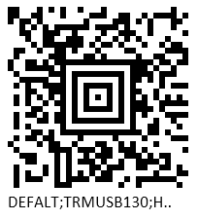
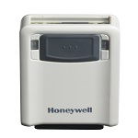
Suffix: ETX

